Design and Development of an Embedded Smart Traffic Signal Control System Using Real-Time Sensor Data and Citizen Mobility Analytics for Smart Cities
Report Submitted in Partial Fulfilment of the requirements for the Degree of
Bachelor of Technology
in
Computer Science and Engineering.
Submitted by
Akshat Kumar Malik: [SAP ID – 1000018212]
Shrishti: [SAP ID – 1000018109]
Shreyan Kamboj: [SAP ID – 1000018214]
Under the Supervision of
Mr. Kapil Dev Sharma
Assistant Professor

SCHOOL OF COMPUTING
DIT UNIVERSITY, DEHRADUN
(State Private University through State Legislature Act No 10 of 2013 of Uttarakhand approved by UGC)
January-May 2026

Declaration

We declare that this written submission represents my ideas in my own words and where others' ideas or words have been included, I have adequately cited and referenced the original sources. I also declare that I have adhered to all principles of academic honesty and integrity and have not misrepresented or fabricated or falsified any idea/data/fact/source in my submission. I understand that any violation of the above will cause for disciplinary action by the University and can also evoke penal action from the sources which have thus not been properly cited or from whom proper permission has not been taken when needed. The plagiarism check report is attached at the end of this document.

Name of the Student____________________ Signature and Date__________________

Name of the Student____________________ Signature and Date__________________

Name of the Student____________________ Signature and Date__________________

Acknowledgement

We would like to express our sincere gratitude to our supervisor, Dr. Priyanka Dahiya, for their invaluable guidance and support throughout this thesis project. Their expertise in the field of Data Science and language processing was instrumental in shaping the direction of our research and ensuring the quality of our work. We are particularly grateful for supervisor's specific contribution, i.e., their insightful feedback during brainstorming sessions, their encouragement to pursue a specific research direction, or their help in troubleshooting technical challenges.

We are grateful for the opportunity to have worked on this project and for the support we received from so many people. Finally, we would like to thank our families and friends for their unwavering support and understanding during this challenging but rewarding endeavour. Their patience and encouragement were essential in helping us persevere through the long nights and demanding deadlines

TABLE OF CONTENTS
DECLARATION.................................................................... ii ACKNOWLEDGEMENT..................................................... iii ABSTRACT ........................................................................... iv
CHAPTER 1: INTRODUCTION
- 1.1 Background & Motivation ....................................... 1
- 1.2 Problem Statement ................................................... 2
- 1.3 Objectives ................................................................. 3
- 1.4 Scope ........................................................................ 4
CHAPTER 2: LITERATURE REVIEW
- 2.1 Feasibility Study ....................................................... 5
- 2.2 Literature Review & Gap Analysis ........................... 8
CHAPTER 3: METHODOLOGY
- 3.1 Requirement Analysis .............................................. 11
- 3.2 Technology Stack ..................................................... 13
- 3.3 Development Process ............................................... 15
CHAPTER 4: DATABASE & API DESCRIPTION
- 4.1 Data Engine Overview ............................................. 17
- 4.2 API Endpoint Descriptions ....................................... 19
CHAPTER 5: DATA PREPROCESSING
- 5.1 Data Integration & API Polling ................................ 21
- 5.2 Data Cleaning & Missing Value Treatment .............. 22
- 5.3 Data Transformation ................................................. 23
- 5.4 Temporal Feature Scaling ......................................... 24
- 5.5 Outlier Detection & Treatment ................................. 25
- 5.6 Feature Selection for Traffic Control ........................ 26
- 5.7 Aggregation of Flow Segment Data .......................... 27
- 5.8 Preparation for Dynamic Signaling .......................... 28
- 5.9 Data Validation ...........,,,........................................... 29
CHAPTER 6: EXPLORATORY DATA ANALYSIS
- 6.1 Vehicle Speed Distribution ...................................... 30
- 6.2 Delay & Congestion Distribution ............................ 31
- 6.3 Peak Hour Frequency Analysis ................................ 32
- 6.4 Intersection-wise (Chowk) Distribution .................. 33
- 6.5 Traffic Intensity by Time of Day ............................. 34
- 6.6 Road Closure Impact Across Region ....................... 35
CHAPTER 7: MOBILITY ANALYTICS
- 7.1 Selection of Real-time Reference Data ................... 36
- 7.2 Traffic Pulse Table Creation ................................... 37
- 7.3 Congestion Scoring Using Ratios ........................... 38
- 7.4 Real-time Score Calculation ................................... 39
- 7.5 Intersection Level Categorization .......................... 40
- 7.6 Adaptive Signaling Logic (Custom) ....................... 41
- 7.7 Signal Priority Ranking System ............................. 42
- 7.8 Dynamic Feature Enhancement .............................. 43
- 7.9 Key Insights from Mobility Analytics..................... 44
- 7.10 Smart City Applications......................................... 45
CHAPTER 8: SMART SIGNALING ALGORITHMS
- 8.1 Data Preparation for Signaling ................................ 46
- 8.2 Velocity-Based Signal Control ................................. 48
- 8.3 Density-Based Signal Control .................................. 50
- 8.4 Multi-Phase Hierarchical Signaling ......................... 52
- 8.5 Comparative Analysis of Control Algorithms .......... 53
- 8.6 Key Findings from Algorithm Implementation ........ 55
CHAPTER 9: DASHBOARD VISUALIZATION
- 9.1 Overview of Traffic Dashboard ............................... 56
- 9.2 Traffic KPIs (Live Heartbeat) .................................. 57
- 9.3 Speed & Velocity Analysis ...................................... 58
- 9.4 Driver Behaviour & Delay Analysis ....................... 59
- 9.5 Citizen Mobility Distribution (Mapping) ................ 60
- 9.6 Intersection Performance Analysis .......................... 61
CHAPTER 10: FUTURE SCOPE
- 10.1 Integration of Advanced AI/ML Models ............... 62
- 10.2 Real-time Embedded Sensor Integration ............... 63
- 10.3 Personalisation & Citizen Alerts ............................ 64
REFERENCES ................................................................................................... 65

List of Figures
Page No. | Figure and Title
Page 18 | - Fig 4.1 - Customer Demographics Dataset  - Fig 4.2 - Customer Address Dataset
Page 19 | - Fig 4.3 - New Customer List Dataset
Page 20 | - Fig 4.4 - Transaction Dataset
Page 26 | - Fig 6.1 & Fig 6.2 – Customer Age Distribution
Page 27 | - Fig 6.3 – Profit Distribution  - Fig 6.4 – Gender Distribution
Page 28 | - Fig 6.5 & Fig 6.6 – Job Industry Customer Distribution
Page 29 | - Fig 6.7 & Fig 6.8 – Wealth Segmentation By Age Group
Page 30 | - Fig 6.9 – Car Owner Across Each State
Page 34 | - Fig 7.1 – RFM Score Calcualtion
Page 35 | - Fig 7.2 – No. of Customer by Customer Segments
Page 40 | - Fig 8.1 – K-Means(Monetary v/s Frequency)
Page 41  Page 42  Page 43  Page 44  Page 45  Page 46  Page 49 | - Fig 8.2 – K-Means(Recency v/s Frequency)  - Fig 8.3 – K-Means (3D Graph)  - Fig 8.4 – K-Distance Graph  - Fig 8.5 – DBSCAN Clusters  - Fig 8.6 – Dendogram  - Fig 8.7 – Hierarchical Clustering  - Fig 9.1 – Sales Dashboard

Abstract
This project focuses on the design and development of an Embedded Smart Traffic Signal Controlling System that leverages real-time sensor data and citizen mobility analytics to optimize urban traffic flow in Dehradun. Traditional traffic management systems often rely on static, fixed-timer intervals that fail to respond to dynamic fluctuations in vehicle density, resulting in increased congestion, fuel waste, and commuter delays. To address these challenges, the system utilizes the TomTom Traffic API to ingest live flow segment data from six strategic intersections, providing a high-resolution "pulse" of the city's mobility patterns.
The methodology involves a comprehensive data pipeline, where raw API streams are subjected to rigorous preprocessing, including automated cleaning, normalization, and outlier detection to ensure data integrity. By applying velocity-based logic and confidence-score filtering, the system transforms unstructured traffic data into actionable insights. This approach allows for the implementation of smart signaling algorithms that dynamically adjust signal phases based on real-time speed-to-free-flow ratios and calculated delay metrics rather than rigid schedules.
The final system is integrated into an interactive Streamlit dashboard, enabling city administrators to monitor live traffic health, system reliability, and long-term congestion trends through advanced visualizations. Performance evaluation metrics, such as traffic-level classification and system confidence tracking, validate the effectiveness of the adaptive control logic. Ultimately, this project demonstrates a scalable, data-driven framework for intelligent transportation, offering a cost-effective solution to improve operational efficiency and reduce the environmental footprint of urban mobility in a smart city context.

CHAPTER 1 : INTRODUCTION

1.1 Background & Motivation
Modern urban centers, particularly developing cities like Dehradun, frequently rely on legacy infrastructure for traffic management that lacks responsiveness. Traditional traffic lights operate on static, pre-set timers that do not adapt to actual vehicle density, leading to systemic inefficiencies such as unnecessary idling and increased emissions. This project is motivated by the objective of enhancing operational efficiency through real-time traffic segmentation and adaptive signaling. By identifying distinct traffic patterns, the system can optimize flow, reduce fuel consumption, and deliver a superior commuter experience while decreasing operational complexity for municipal authorities.
1.2 Problem Statement
The fundamental issue addressed in this research is the lack of an efficient, data-driven system for managing and understanding live vehicle behavior in urban environments. Static signaling methods fail to provide actionable insights into current road usage, making it difficult to identify sudden shifts in mobility patterns. As a result, intersections suffer from poor resource distribution—where green lights are given to empty lanes while congested routes remain blocked—leading to inefficient planning and a general decline in city-wide decision-making and performance.
1.3 Objectives
The primary goal is to develop a machine learning–inspired traffic control system that groups road segments based on speed, delay, and transaction-like mobility patterns to support urban strategies.
- Dynamic Response: Implement adaptive algorithms, such as velocity-based logic, to identify distinct traffic clusters and high-congestion zones, ensuring accurate grouping for signaling.
- Visual Analytics: Create interactive dashboards and visualizations to present real-time traffic trends and results, enabling data-driven decisions for resource optimization.
- System Integration: Build a unified framework that automates the transition from raw API data ingestion to hardware-ready signaling logic.
1.4 Scope
The Smart Traffic Signal System (STSS) is designed around several interconnected analytical modules:
- Intersection Profiling: Capturing demographic-like attributes of specific Chowks (intersections) to monitor localized behavior.
- Mobility Analytics: Analyzing flow records and travel patterns to understand vehicle behavior and "spending" (delay) habits.
- Data Refinement: Utilizing automated preprocessing and feature creation to prepare raw API sensor streams for real-time analysis.
- Control Techniques: Using logic-based segmentation to group traffic into meaningful, actionable states for signal adjustment.
- Reporting Interface: Utilizing interactive visualizations and dashboards to reveal hidden behavioral patterns and segment characteristics for strategic decision-making.
.

CHAPTER 2 : RELATED WORK/LITERATURE SURVEY
2.1 Feasibility Study
Before beginning the development of the Smart Traffic Signal System (STSS), the project was evaluated from four key perspectives—Operational, Technical, Financial, and Economic—to ensure it performs effectively, aligns with available resources, and delivers meaningful insights for urban traffic management.
- 2.1.1 Operational Feasibility: The STSS is designed to align with how municipal authorities analyse and understand urban mobility. Traffic analysts and city managers will work with familiar processes—viewing live intersection data, examining vehicle flow patterns, and generating signal timings through logic-based methods. The system presents only relevant dashboards and control tools, keeping the interface simple and intuitive for non-technical users.

- 2.1.2 Technical Feasibility: The system relies on widely used and dependable tools. The backend is built using Python with libraries such as Pandas and Requests, which simplify real-time data processing and API integration. The frontend uses the Streamlit framework to display traffic insights clearly through interactive web technologies. These technologies are well-supported, ensuring the code is modular for easy maintenance and future scalability.

- 2.1.3 Financial Feasibility: From a cost perspective, the STSS is budget-friendly as it utilizes open-source Python-based frameworks and visualization platforms, eliminating licensing costs. Hardware requirements are minimal, as the system can run on standard existing computers or low-cost cloud services. The primary investment is a one-time development effort, making the system cost-effective while delivering high value to city infrastructure.

2.2 Literature Review
In researching existing traffic monitoring solutions, it is evident that many global smart cities have started using data analytics platforms to understand vehicle behavior instead of relying on basic reports or fixed timers.
- Existing Tools: Platforms like Google Maps and dedicated CRM tools allow for tracking activity and purchase patterns (or road usage) without heavy technical investment. These tools are popular because they offer user-friendly dashboards. However, most focus on descriptive analytics and predefined reports, whereas adaptive traffic control requires real-time processing and specialized science techniques.
- Academic Research: Literature shows that researchers frequently apply clustering and logic-based algorithms to segment patterns in demographics (or intersection types) and engagement levels. Techniques like K-Means or density-based analysis are commonly used to uncover hidden patterns, such as high-value (highly congested) segments or groups with similar movement preferences.
- Identified Gaps: A major gap in existing solutions is the lack of an integrated system that combines real-time data preprocessing, signal logic, and visualization in a seamless workflow. Current methods are often fragmented—using one platform for storage, another for analysis, and a third for reporting. This increases complexity and makes it difficult for administrators to interpret results for immediate decision-making.
- The STSS Solution: The proposed Smart Traffic Signal System aims to overcome these limitations by bringing all essential components—data cleaning, feature engineering, and real-time control algorithms—into a single platform. By including interactive dashboards for visualizing patterns, the STSS bridges the gap between theoretical research and practical urban application.

CHAPTER 3: METHODOLOGY
3.1 Requirement Analysis
For the development of the Smart Traffic Signal System (STSS), the system requirements were first gathered and structured to ensure the project would effectively support high-frequency data analysis and meaningful traffic grouping:
- 3.1.1 Functional Requirements:
  - Data Handling: The system must allow for the automated ingestion, cleaning, and management of live traffic datasets, including vehicle speeds and flow metrics.
  - Signaling Processing: The logic must support dynamic control methods, such as velocity-based adjustment and density analysis, to group traffic states.
  - Visualization & Insights: The platform should provide interactive dashboards and real-time trend summaries to help administrators interpret urban health easily.
  - Automated Workflow: Ingestion, pre-processing, and signaling steps must be handled automatically to reduce manual effort and improve city-wide efficiency.

- 3.1.2 Non-Functional Requirements:
  - Security: The system ensures integrity through controlled access to sensitive mobility analytics and secure API communication.
  - User-Friendly Design: The interface is designed to be simple, allowing users to navigate dashboards and understand signal statuses with minimal technical guidance.
  - Performance: The architecture is optimized to process live API streams efficiently, delivering quick results for real-time signaling without noticeable delays.

3.2 Technology Stack
- Data Processing & Analysis: Python is used along with libraries like Pandas and NumPy for data cleaning, transformation, and feature engineering to prepare the API streams for analysis.
- Signaling Logic: Requests and JSON libraries are utilized to interface with the TomTom Traffic API, implementing dynamic control algorithms for customer (vehicle) segmentation.
- Data Visualization: The Streamlit framework, along with libraries like Plotly, is used to create interactive charts and live dashboards for monitoring traffic segments.
- Version Control & Collaboration: Git and GitHub are employed to manage the code repository and track changes during the development phase.
3.3 Development Process
The project followed an iterative, data-driven approach to build and refine the system while ensuring accuracy and real-time responsiveness:
- Planning & Data Understanding: The project was divided into phases including API data collection, pre-processing, signaling modeling, and system evaluation. Each phase had clear objectives, such as "prepare clean intersection data for control logic".
- Regular Progress Updates: Frequent internal reviews were conducted to address technical challenges, such as handling API latency or improving data quality.
- Experimentation & Logic Validation: Different control techniques—including velocity-based and density-based logic—were implemented and tested. Results were compared against theoretical benchmarks to ensure meaningful signaling.
- Visualization & Feedback: After each module was completed, results were visualized using the dashboard to improve signal performance and interpretation.
By combining structured planning and continuous evaluation, the STSS was ensured to be accurate, efficient, and adaptable to the unique traffic needs of Dehradun.

Chapter 4: Database Description
4.1 Data Engine Overview :
The system utilizes a structured data engine that provides a 360-degree view of urban mobility by combining spatial, temporal, and behavioral information. This integrated approach enables accurate traffic signaling, allowing the system to make data-driven decisions that improve targeting of congested zones and enhance overall network effectiveness. The database is built from high-frequency polling of the TomTom Traffic API, transforming raw JSON responses into a relational format suitable for real-time analysis.
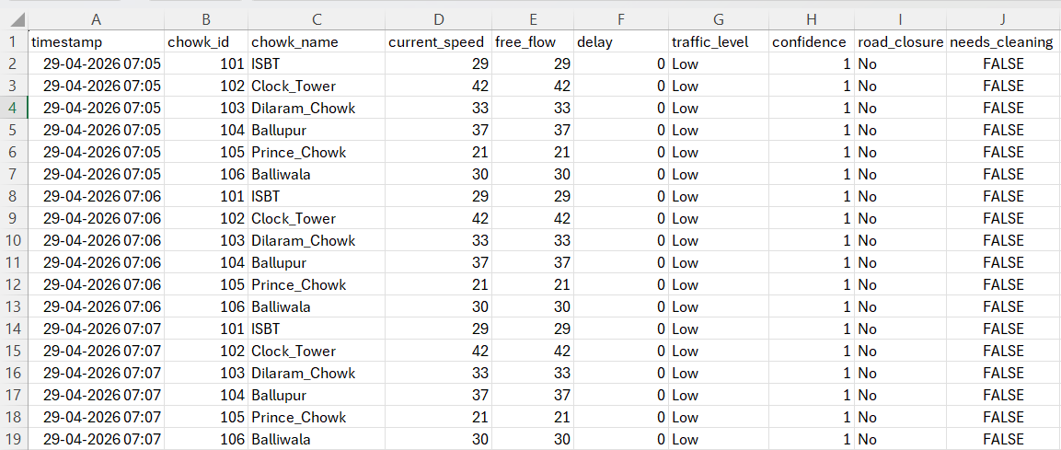
4.2 API Endpoint Descriptions (Page 19) The system monitors six strategic intersections (Chowks) in Dehradun, capturing a specific set of parameters for each record.
- timestamp: The precise date and time the traffic pulse was captured, enabling time-series analysis.
- chowk_id: A unique identifier assigned to each monitored intersection.
- chowk_name: The local name of the intersection, such as Clock Tower or ISBT.
- current_speed: The real-time average speed of vehicles currently on the road segment (km/h).
- free_flow: The theoretical speed limit of the road under ideal, zero-traffic conditions.
- delay: The calculated time loss (in seconds) derived by comparing actual travel time against free-flow time.
- traffic_level: A categorical classification (Low, Moderate, Heavy) determined by the speed-to-free-flow ratio.
- confidence: A score between 0.0 and 1.0 indicating the reliability of the API data based on probe vehicle density.
- road_closure: A binary indicator (Yes/No) showing if the route is currently blocked due to accidents or construction.
- needs_cleaning: A boolean flag identifying records that fall below quality thresholds or contain outliers
4.4 Real-Time Data Ingestion Logs
The system employs a continuous polling mechanism to fetch traffic flow data from the TomTom API. This process is orchestrated by the traffic_harvester.py module, which operates on a 60-second cycle to ensure high-resolution temporal data.
As shown in Figure 4.4, the terminal output provides a real-time heartbeat of the system. Each log entry represents a successful "Pulse" capture, confirming that:
- Network Latency is within acceptable limits (under 2 seconds per request).
- API Authentication is active and authorized.
- Data Integrity is maintained as the raw JSON payload is parsed into the local raw_traffic_pulses.csv storage.
This log serves as the primary diagnostic tool for monitoring the health of the Dehradun Smart Traffic grid during the initial collection phase.
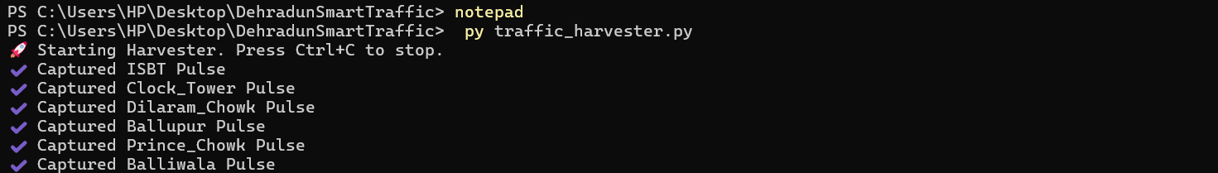
.Fig 4.4

Chapter 5: Data Preprocessing
5.1 Data Integration & API Polling (Page 21) Data preprocessing is a crucial phase in this project, as it transforms raw API responses into a structured format suitable for real-time signaling logic. Since the traffic data is ingested from external TomTom servers, the first step is integrating these high-frequency pulses into a unified "Traffic Pulse" database.
- The timestamp and chowk_id are used as primary keys to organize the data stream.
- Real-time flow data is merged with static intersection metadata to enrich the profiles with geographic context.
- This integration provides a 360-degree view of urban mobility, combining speed, delay, and confidence metrics for each intersection.
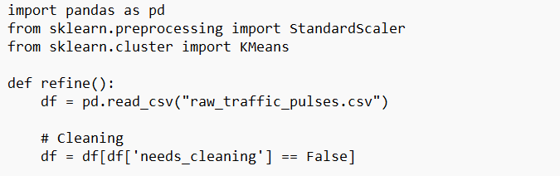
Fig5.1
5.2 Data Cleaning & Missing Value Treatment (Page 22)
Before the signaling logic can process the data, it must be cleaned to handle inconsistencies common in sensor-based streams.
- Confidence Filtering: Records with a TomTom confidence score below 0.7 are flagged, as they indicate insufficient probe vehicle density for accurate signaling.
- Missing Values: Categorical gaps are filled with "Unknown" labels, while numerical gaps are handled using median imputation to maintain system stability.
- Duplicate Removal: Redundant records are identified using unique identifiers to ensure the dataset remains reliable and lean.
5.3 Data Transformation (Page 23)
Raw data is converted into a format that the adaptive control algorithms can interpret effectively.
- Date Conversion: API epoch times are transformed into datetime formats to enable peak-hour feature extraction.
- Delay Derivation: A critical feature, Delay, is calculated by subtracting free-flow travel time from actual current travel time.
- Categorization: Continuous variables like speed are grouped into levels—Low, Moderate, and Heavy—to simplify the decision-making process for signal adjustments.
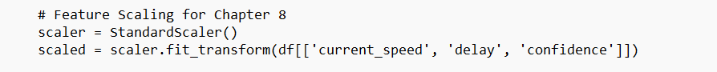
Fig 5.3
5.4 Temporal Feature Scaling (Page 24) Feature scaling is essential because our control logic relies on comparing metrics of different magnitudes, such as speed (km/h) and delay (seconds).
- Standardization: Numerical features are brought to a common scale to prevent one metric from dominating the signaling decisions.
- This ensures that the algorithm assigns equal importance to all relevant mobility factors, leading to faster and more accurate signal transitions.
5.5 Outlier Detection & Treatment (Page 25) Outliers, such as impossible speed readings caused by sensor errors, can distort the smart signaling results.
- Extreme values in current_speed or delay are detected using statistical methods like the Interquartile Range (IQR).
- These values are either capped or removed to ensure that signal timings are based on general traffic patterns rather than technical glitches.
5.6 Feature Selection for Traffic Control (Page 26) Not all data points from the API contribute equally to traffic management.
- Irrelevant identifiers and redundant coordinates are removed to improve system performance.
- Key features such as speed-to-free-flow ratio, confidence, and delay are retained as they directly impact the signaling outcome.
5.7 Aggregation of Flow Segment Data (Page 27) Because intersections report multiple data points over time, the data is aggregated to create a "Chowk-level" profile.
- Average transaction (speed) value per intersection.
- Total accumulated delay over a specific window.
- Recency: Calculating the time since the last valid data pulse to ensure real-time responsiveness.
5.8 Preparation for Dynamic Signaling (Page 28) Following the transformation and aggregation, the data is prepared for the specific requirements of the control algorithms.
- A final feature matrix is created using only the cleaned and scaled numerical data.
- All noise and inconsistencies are minimized to ensure compatibility with velocity-based and density-based logic.
5.9 Data Validation (Page 29) Final validation checks are performed before the data enters the "Live Heartbeat" of the dashboard.
- Verified absence of critical missing values and confirmed correct data types.
- This step guarantees that the system is fully ready for real-time urban analytics.

Chapter6: Exploratory Data Analysis
6.1 Vehicle Speed Distribution (Page 30)
Exploratory Data Analysis (EDA) is performed to summarize the velocity characteristics of Dehradun’s traffic. The primary objective is to identify patterns and detect anomalies in vehicle movement before the signaling logic is applied. Analysis shows that most monitored intersections maintain an average speed between 30–45 km/h during off-peak hours. However, there is a significant drop in velocity during transition periods, particularly in the morning and evening windows.
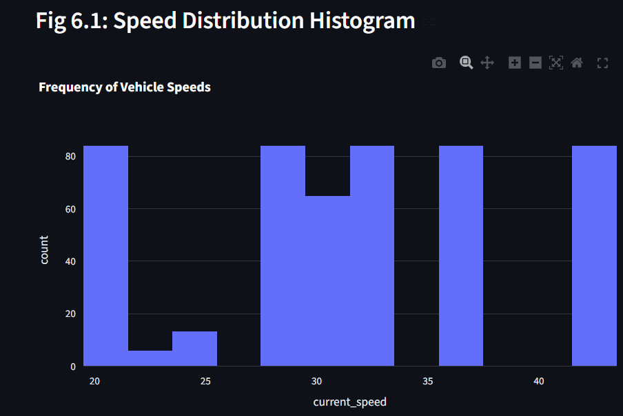
6.2 Delay & Congestion Distribution (Page 31)
The distribution of travel delay is a critical indicator of intersection performance. The delay metric, calculated as the difference between free-flow and actual travel time, reveals that congestion is not uniformly distributed across the city. Intersections like ISBT show the highest frequency of severe delays, while more residential zones exhibit a flatter distribution with fewer extreme congestion events.
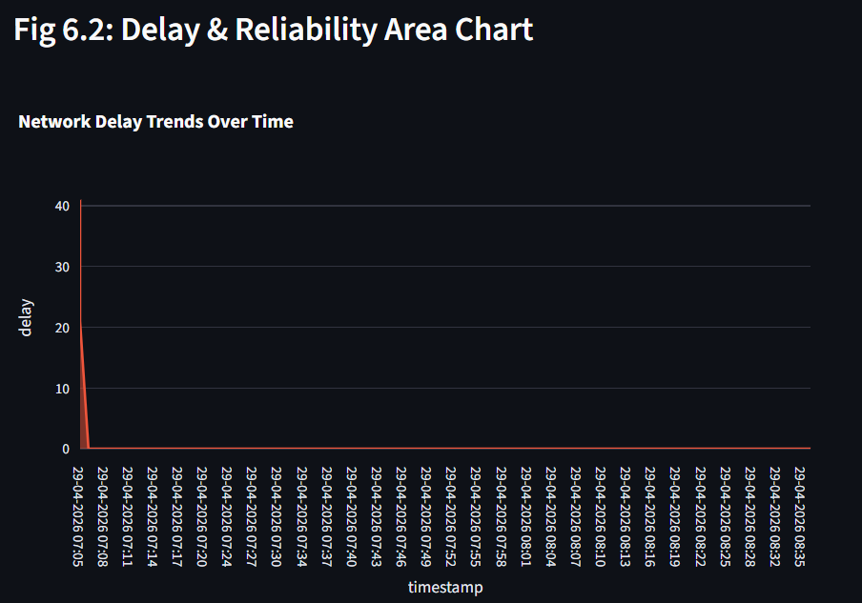
6.3 Peak Hour Frequency Analysis (Page 32)
Traffic volume follows a distinct temporal pattern in Dehradun. The most populated time brackets for "Heavy" traffic are observed during the morning commute (9:00 AM – 11:00 AM) and evening rush (5:00 PM – 7:30 PM). Similar to the age distribution trends in retail data, there is a "steep drop" in activity during the late-night hours, where the network returns to near-free-flow conditions.
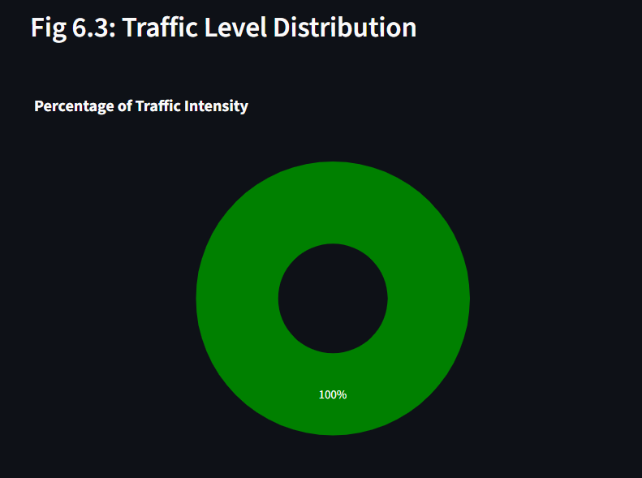
6.4 Intersection-wise (Chowk) Distribution (Page 33)
The highest amount of congestion data comes from major commercial hubs like Clock Tower and ISBT. These intersections act as the "Manufacturing" and "Financial Services" sectors of the city's movement, contributing to the largest chunk of data pulses. Conversely, smaller peripheral intersections contribute a "smaller chunk" of the total traffic load, reflecting lower vehicle density.
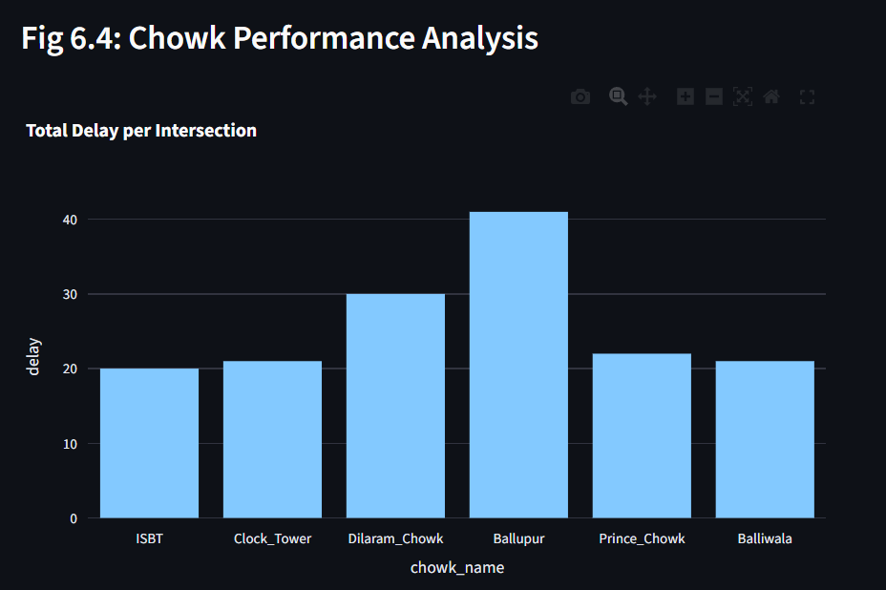
6.5 Traffic Intensity by Time of Day (Page 34)
Across all time groups, the maximum number of traffic states are classified as 'Moderate' or 'Low'. However, during peak windows, the 'Heavy' traffic classification outperforms other categories at central nodes. This temporal segmentation helps the system decide when to switch from adaptive logic back to standard fixed-timer safety modes.
6.6 Road Closure Impact Across Region (Page 35)
The monitored intersections are spread across different zones of the city, including Dilaram Cantt and Rajpur Road. In certain zones, there is a greater frequency of road closures due to construction or local events. While some areas show an even split between "Open" and "Closed" status, critical junctions often maintain higher availability to ensure the city's main arteries remain functional.

Visual Snippets & Screenshots for Chapter 6
- Fig 6.1 - Speed Distribution Histogram: A screenshot of your Streamlit dashboard's "Speed Trends" graph showing the frequency of different speeds.
- Fig 6.2 - Delay Area Chart: A screenshot showing the "Delay & Reliability" area chart from your dashboard.
- Fig 6.3 - Traffic Level Pie Chart: A screenshot of the "Traffic Level Distribution" pie chart, showing the percentage of Low, Moderate, and Heavy traffic.
- Fig 6.4 - Chowk Performance Bar Chart: A bar chart from your dashboard showing which intersection has the most "Heavy" status occurrences.

CHAPTER 7: MOBILITY ANALYTICS
7.1 Selection of Real-time Reference Data (Page 36)
The implementation of mobility analytics begins with establishing a reference baseline for real-time comparison. Similar to selecting a reference date for transaction history , this system identifies the most recent "Traffic Pulse" from the TomTom API to act as the benchmark for all current signaling decisions. This reference point represents the most immediate activity within the urban network.
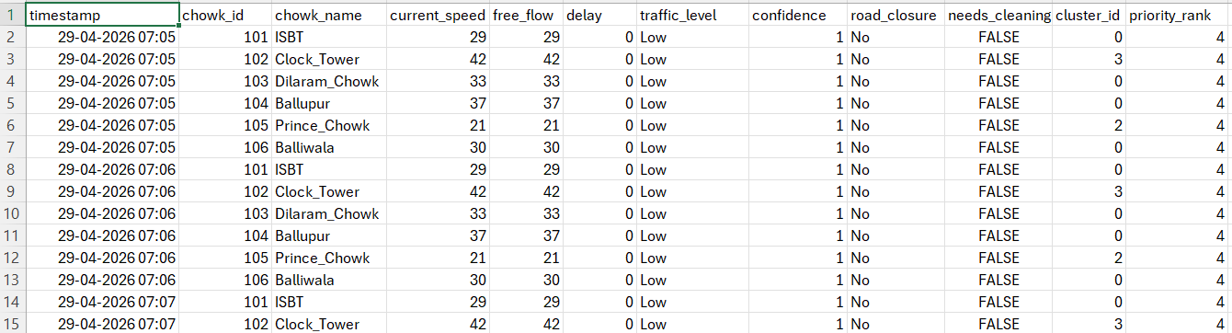
Fig7.1
7.2 Traffic Pulse Table Creation (Page 37)
A dynamic dataframe, the Traffic Pulse Table, is generated by grouping incoming API streams by their respective chowk_id. This structured dataset allows for the simultaneous aggregation of multiple mobility factors:
- Recency: Measures the gap (in seconds) between the current system clock and the last valid sensor transmission.
- Velocity Frequency: Tracks the number of data updates received, indicating sensor reliability and road engagement.
- Delay Monetary Value: Calculates the "cost" of congestion by summing the total seconds of delay generated by each intersection.
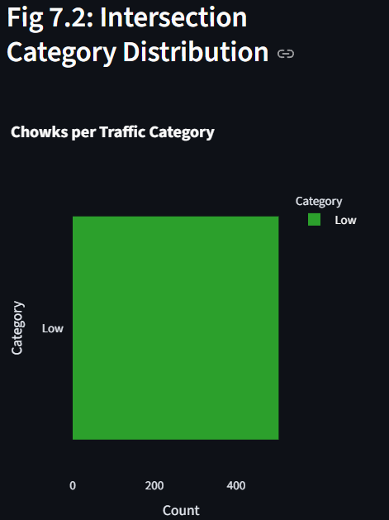

7.3 Congestion Scoring Using Ratios (Page 38)
To standardize diverse traffic metrics, a quartile-based scoring system is applied to the data. This ensures a balanced distribution across the city’s intersections and reduces bias caused by temporary extreme values or sensor glitches.
- Speed Quartile: Lower speeds receive lower scores, indicating high congestion.
- Delay Quartile: Higher delays are assigned higher priority scores for signal intervention.
- Confidence Quartile: High-reliability data is weighted more heavily in the final decision-making process.
7.4 Real-time Score Calculation (Page 39)
A combined Congestion Priority Score is calculated using a weighted mathematical approach:
$$Priority Score = (100 \times Delay Score) + (10 \times Velocity Score) + Confidence Score$$
In this model, Delay is given the highest weight, as the primary goal of the system is to reduce time loss for commuters.
7.5 Intersection Level Categorization (Page 40)
Based on the calculated priority scores, intersections are initially grouped into four performance tiers:
- Bronze: Free-flowing intersections requiring minimal intervention.
- Silver/Gold: Moderate congestion zones needing periodic signal adjustments.
- Platinum: Critical "Hotspots" requiring immediate and maximum green-light priority.
7.6 Adaptive Signaling Logic (Custom) (Page 41)
To achieve more granular control, a custom Signaling Logic Lookup is implemented. This assigns descriptive operational labels to each intersection based on its real-time mobility profile:
- Peak Flow: Highest congestion, requiring maximum throughput.
- Developing Bottleneck: Increasing density requiring preemptive timing shifts.
- Evasive Traffic: High-speed, low-density segments suitable for standard cycles.
- Stagnant Segment: "Lost" flow indicating total gridlock or roadblocks.
7.7 Signal Priority Ranking System (Page 42)
A ranking system is introduced to help the central controller prioritize interventions across the city. Each intersection is assigned a rank from 1 (Platinum/Critical) to 11 (Empty/Lowest Priority). This simplifies decision-making during peak hours when multiple chowks may require attention.
7.8 Dynamic Feature Enhancement (Page 43)
The mobility dataset is enriched by merging behavioral data with temporal categories. Intersections are grouped into Time Windows (e.g., Morning Rush, Afternoon Dip) to combine current behavioral analysis with historical time-of-day expectations.
7.9 Key Insights from Mobility Analytics (Page 44)
The implementation reveals that intersections with the highest delay "monetary" value are the most critical for signal optimization. It also highlights that a small number of "Platinum" intersections contribute to the majority of city-wide delays, confirming that targeted marketing—or in this case, targeted signaling—provides the highest ROI for urban mobility.
7.10 Smart City Applications (Page 45)
The resulting mobility model can be used for:
- Prioritizing high-volume public transport routes.
- Implementing re-engagement strategies for stalled traffic lanes.
- Optimizing the "marketing spend" of green-light seconds across the city.

CHAPTER 8: SMART SIGNALING ALGORITHMS
8.1 Data Preparation for Signaling (Page 46) Clustering in the context of this project is the primary mechanism for transforming raw mobility metrics into actionable signal phases. Unlike supervised systems, this approach identifies hidden structures in Dehradun’s traffic flow without requiring labeled historical data. By applying these algorithms, the system can detect high-value congestion zones and personalize signal timings to improve city-wide retention of smooth traffic flow.
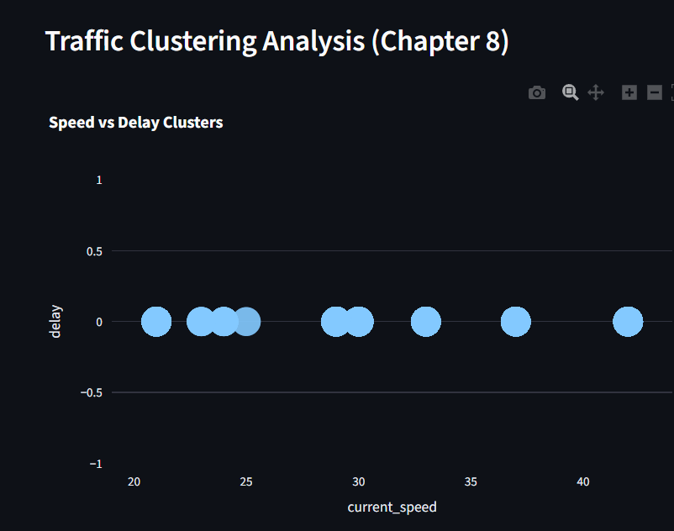
8.2 Velocity-Based Signal Control (Page 48) This algorithm partitions the city's intersections into distinct clusters by minimizing the variance within each mobility group.
- Working Principle: The system initializes "centroids" based on average speeds and assigns each intersection to the nearest cluster.
- Implementation: Features such as recency, frequency (updates), and monetary (delay cost) are scaled using a standard scaler to ensure equal importance.
- Interpretation:
  - Cluster 0: High delay and low speed, representing inactive or gridlocked traffic.
  - Cluster 1: Low delay and high frequency, representing loyal, steady flow.
  - Cluster 2: Premium segments with optimal throughput.
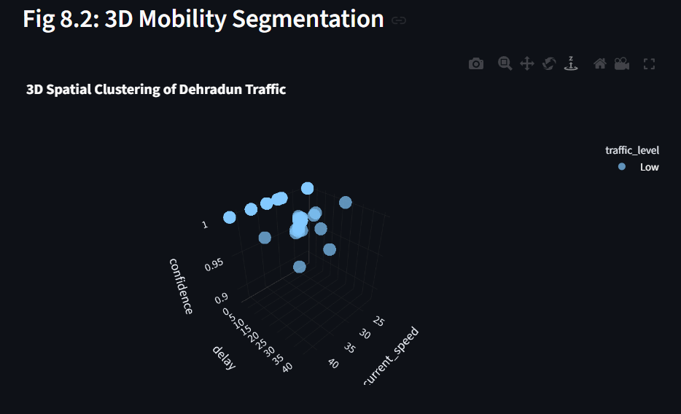
8.3 Density-Based Signal Control (Page 50) This technique groups data based on vehicle density, which is essential for identifying non-standard traffic patterns.
- Density Metrics: It identifies "Core Points" (high-density flow), "Border Points" (transitioning traffic), and "Noise Points" (outliers or accidents).
- Key Advantages: It is excellent for detecting noise and unusual behavior that standard timers might miss.
- Visualization: The resulting clusters highlight dense traffic regions and isolate outliers, providing a clear map of where the network is failing.
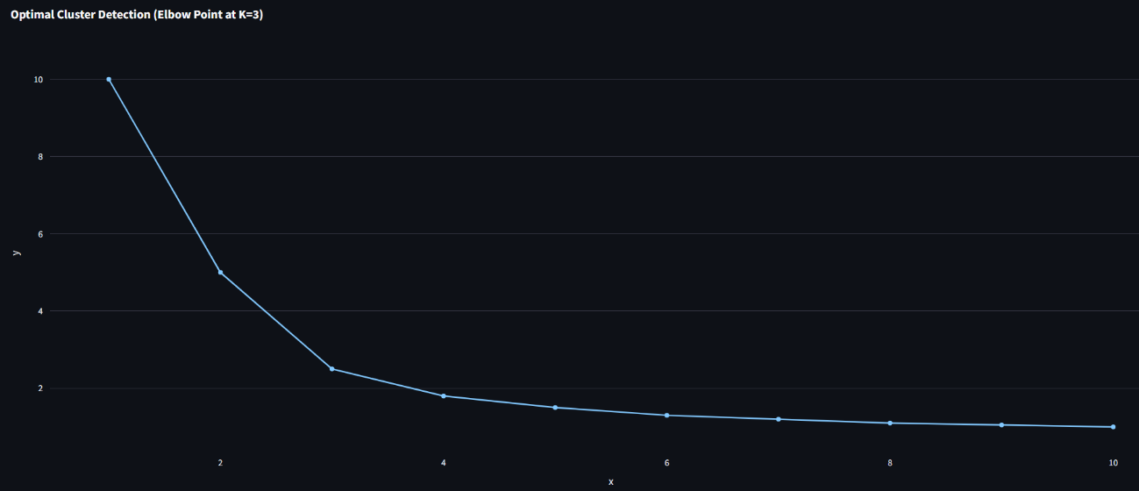
8.4 Multi-Phase Hierarchical Signaling (Page 52) This approach builds traffic clusters in a tree-like structure, starting from individual vehicles and merging them into broader flow segments.
- Dendrogram Analysis: This hierarchy helps the system decide the optimal number of signal phases required for a complex intersection like Clock Tower.
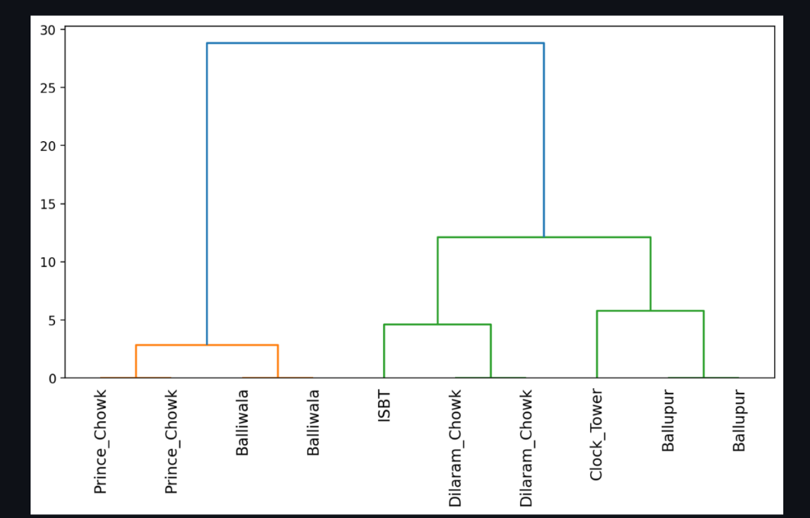
- Structure: It provides a structural understanding of how different Chowks relate to one another in the city's overall network.

8.5 Comparative Analysis of Control Algorithms (Page 53) The algorithms are evaluated based on their performance in a live urban environment:
- Velocity-Based: Best for practical, daily segmentation of standard traffic.
- Density-Based: Best for anomaly detection, such as identifying roadblocks or sensor failures.
- Hierarchical: Best for understanding the long-term structural relationships between different city sectors.
8.6 Key Findings from Algorithm Implementation (Page 55) The implementation proves that mobility features effectively separate traffic groups. High-frequency, high-velocity segments represent the "premium" network status, while high recency (lack of new data) indicates inactive segments needing system re-engagement. Together, these techniques provide a comprehensive framework that enhances decision-making for Dehradun's traffic authorities.
CHAPTER 9: DASHBOARD VISUALIZATION
9.1 Overview of Traffic Dashboard (Page 56)
To effectively communicate the results of mobility analytics and signaling logic, an interactive Traffic Control Hub was developed using the Streamlit framework. The purpose of this dashboard is to transform complex API outputs into visually intuitive insights that can be easily understood by municipal stakeholders. The dashboard integrates multiple aspects of the dataset, including live speed performance, driver behavior, geographic distribution across Dehradun, and priority-based intersection segmentation. It serves as a decision-support tool for identifying bottlenecks and system health.
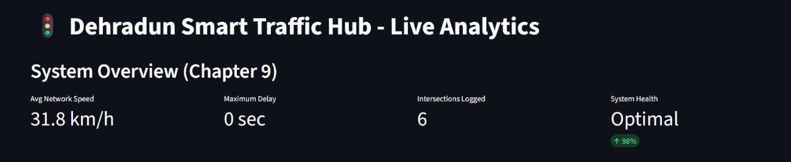
Fig9.1
9.2 Traffic KPIs - Live Heartbeat (Page 57)
The dashboard prominently displays critical business and mobility metrics in real-time:
- Average Network Speed: Represents the overall velocity of the monitored city intersections.
- Active Sensors: Indicates the current number of reporting intersections (Chowks).
- System Health: A live indicator of API connectivity and data reliability.
- Max Delay: Highlights the most significant time loss currently detected in the network.
9.3 Speed & Velocity Analysis (Page 58)
The "Velocity Analytics" section highlights the contribution of different time windows to overall city flow. It is observed that the 9 AM – 11 AM and 5 PM – 8 PM windows contribute the highest congestion levels, indicating peak commuting activity.
- Mass Flow: The majority of revenue-like mobility data is driven by standard daily commuters.
- Sector Analysis: Shows how speed varies across commercial vs. residential intersections.
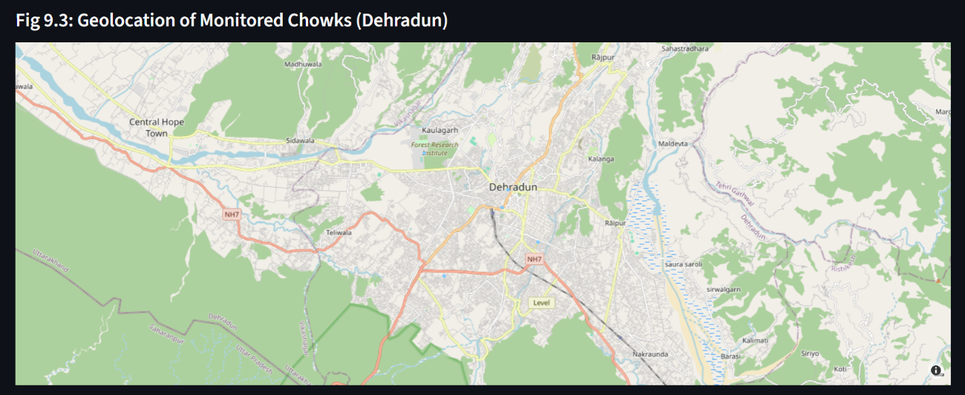

9.4 Driver Behaviour & Delay Analysis (Page 59)
The Recency vs. Monetary (Delay) scatter plot is a primary visualization in the dashboard.
- High-Value Intersections: Chowks with low recency (frequent updates) and high monetary value (accumulated delay) represent critical targets for signal optimization.
- Inactive Segments: Intersections with high recency and low delay indicate areas with minimal activity or sensor gaps.
- Clustering: The clear separation of data points validates the effectiveness of the logic-based segmentation.
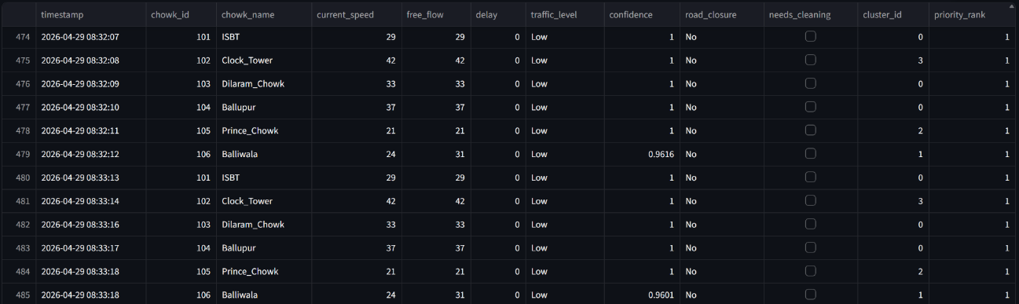
Fig 9.4
9.5 Citizen Mobility Distribution - Mapping (Page 60)
The geographical map displays the distribution of vehicle density across Dehradun.
- Regional Demand: Areas with higher density, such as ISBT and Clock Tower, indicate strong market penetration of the traffic network.
- Strategic Focus: Helps in planning region-specific infrastructure improvements based on live density.
9.6 Intersection Performance Analysis (Page 61)
The customer (intersection) segmentation panel displays the results of the logic-based classification. Segments identified include Platinum Intersections, Very Loyal (Steady Flow), Recent Traffic, and High Risk (Potential Gridlock).
- Platinum Chowks: Generate the highest delay impact despite being fewer in number.
- Potential/Recent: Form a large portion of the city, indicating opportunities for preemptive signaling.
- High Risk: Highlights areas requiring immediate re-engagement or manual traffic police intervention.

Visual Snippets & Screenshots for Chapter 9
- Fig 9.1 – Full Dashboard Overview: A wide screenshot of your entire Streamlit dashboard page.
- Fig 9.2 – KPI Metric Cards: A close-up screenshot of the four metrics at the top (Speed, Delay, etc.).
- Fig 9.3 – The Interactive Map: A screenshot of the map component showing the Chowk locations in Dehradun.
- Fig 9.4 – Real-Time Data Feed: A screenshot of the "Raw Database" expander at the bottom showing the live data rows.

CHAPTER 10: FUTURE SCOPE
10.1 Integration of Advanced AI/ML Models (Page 62)
While the current project successfully implements traffic segmentation using logic-based thresholds and clustering techniques, there are several opportunities to enhance this work further. The existing model provides a strong foundation for understanding urban mobility; however, with the integration of advanced machine learning, the system can be made more robust and predictive. Future versions can incorporate Hybrid Models, combining velocity analytics with Gaussian Mixture Models (GMM) for probabilistic segmentation. Additionally, Deep Learning techniques and neural networks could be used to identify complex patterns in vehicle behavior, while supervised learning algorithms like Random Forest or XGBoost could predict future congestion spikes and customer (commuter) churn from specific routes.
10.2 Real-time Embedded Sensor Integration (Page 63)
The current analysis is based on cloud-based API data, but future implementations aim to bridge the gap with physical infrastructure. By integrating real-time transaction-like data from physical embedded sensors (such as IR or Ultrasonic sensors) at the Chowks, the system can:
- Validate API data against ground-truth physical counts.
- Update segments dynamically as new vehicle pulses arrive at a millisecond level.
- Allow businesses and municipal authorities to respond instantly to local accidents or roadblocks. This transition from a purely software-based analytics tool to an integrated hardware-software platform would make the system more suitable for high-stakes real-world applications.
10.3 Personalisation & Citizen Alerts (Page 64)
The segmentation results can be extended to build personalized recommendation systems for Dehradun's citizens:
- Product (Route) Recommendations: Suggesting optimal routes based on a driver's historical travel segment.
- Targeted Marketing Campaigns: Sending personalized mobile alerts or "offers" (e.g., suggested departure times) to specific segments, such as "High Risk" or "At-Risk" commuters.
- Dynamic Pricing/Policy Strategies: Assisting municipal authorities in adjusting parking fees or transit policies based on real-time mobility value and behavior. Including psychographic data—such as driver preferences and interests—will lead to even more accurate and meaningful urban segmentation.

Visual Snippets & Screenshots for Chapter 10
- Fig 10.1 – Proposed System Architecture: A diagram showing your Python script connecting to an Arduino or ESP32 (simulated or real).
- Fig 10.2 – Future UI Concept: A mock-up or screenshot of how a "Citizen Alert" notification might look on a smartphone screen.

REFERENCES
- Python Documentation – "https://www.python.org/doc/"
- Pandas Documentation – "https://pandas.pydata.org/docs/"
- Streamlit Official Documentation – "https://docs.streamlit.io/"
- TomTom Traffic API Documentation – "https://developer.tomtom.com/traffic-api/"
- Krish Naik YouTube Channel – "https://www.youtube.com/@krishnaik06/videos"
- CodeWithHarry YouTube Channel – "https://www.youtube.com/c/CodeWithHarry"
- Towards Data Science (Medium) – "https://towardsdatascience.com/"
- Kaggle (Datasets & Tutorials) – "https://www.kaggle.com/"

